The general formula of alkyl halide is:
A. $C_{n}H_{2n}+1X$
B. $C_{n}H_{2n}+2X$
C. $C_{n}H_{2n+2}+1X$
D. $C_{n}H_{2n-2}+1X$
ANSWER: A
Alkyl halide containing two $β-carbon and one α-hydrogen$is called ___________ alkyl halide
A. Primary
B. Secondary
C. Tertiary
D. Mono
ANSWER: B
Following compound represents:
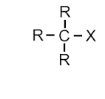
A. Primary alkyl halide
B. Secondary alkyl halide
C. Tertiary alkyl halide
D. None of these
ANSWER: C
Chloroform ($CHCl_{3})$is
A. Primary alkyl halide
B. Secondary alkyl halide
C. Tertiary alkyl halide
D. None of these
ANSWER: D
An alkyl halide in which halogen bearing C atom is directly linked to one more carbon atom is called
A. Primary $1^{0}$
B. Secondary $2^{0}$
C. Tertiary $3^{0}$
D. None of these
ANSWER: A

Common name of $CH_{3}-CH_{2}-CH_{2}-Cl$ is:
A. Ethyl chloride
B. Propyl chloride
C. 1-chloropropane
D. Chloropropane
ANSWER: B
Common name of $C_{4}H_{9}-I$ is:
A. 1-butane iodide
B. Iodo-pentyl
C. 1-iodobutane
D. Butyl iodide
ANSWER: D
Total number of possible structural isomers of $C_{5}H_{11 }Br$ are:
A. 10
B. 4
C. 8
D. 11
ANSWER: C
Halogen group includes:
A. Cl, Br, Na
B. Br, F, Mg
C. I, S, O
D. Cl, Br, I
ANSWER: D
Alkyl halides are also known as __________.
A. Alkanes
B. Halo alkenes
C. Halo alkanes
D. Halo alkynes
ANSWER: C
IUPAC name of $CH_{3}Br$ is:
A. 1-methyl bromide
B. Methyl bromide
C. Bromo methane
D. Methane bromide
ANSWER: C
IUPAC name of the following compound is:
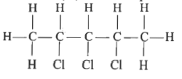
A. Tri-chloro pentane
B. Pentyl-3-chloride
C. 2, 3, 4-tri chloro pentane
D. Pentyl-2, 3, 4- tri chloride
ANSWER: C
Reactivity order of halogens is:
A. $F>Br>Cl>I$
B. $F>Cl>Br>I$
C. $Cl>F>Br>I$
D. $F>Cl>I>Br$
ANSWER: B
IUPAC name of the following compound is:
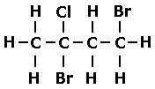
A. 2,4 tri-bromo chloride butane
B. 1,3-dibromo-3-chloro butane
C. 2,4-di bromo-2-chloro butane
D. Butane-1,3-bromo-3-chloro
ANSWER: C
Halogen are ____________ reactive than alkyl group.
A. Less
B. More
C. Equal to
D. None of these
ANSWER: B
IUPAC name of the following compound is:
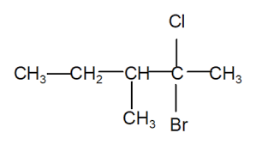
A. 2-bromo-2-chloro-3-methyl-pentane
B. 2-chloro-2-bromo-3-methyl-pentane
C. 3-methyl-4-chloro-4-bromo-pentane
D. 3-methyl-4-bromo-4-chloro-pentane
ANSWER: A

